Contents

Introduction 4

Justification 4

Objectives and Goals 5

Features of System 6

Detailed Requirements 7

• Admin 7

• User 7

System Requirement 8

Hardware requirements 8

Software requirement 9

Workflow diagram 10

System Security Requirement 11

Non-Functional Requirements 13

Class Diagram 14

System mockup 15

Login 15

Add category 15

Add product 16

Add store 16

Products 17

Complains 17

Search on user account 18

Results 18

Risk Assessment 19

Standards 20

High level architecture 21

• **UseCase diagram** 21

• **Activity Diagram** 22

Tools and Processes 23

Project Plan 23

Sub-Team Responsibilities and Team Structure 25

Expected Results 26

REFRANCE 27

List Of Figures

Figure 1 - work flow diagram 10

Figure 2 - class diagram 14

Figure 3 – Login 15

Figure 4 – add category 15

Figure 5 - add product 16

Figure 6 - add store 16

Figure 7- products when logged in as admin 17

Figure 8 - complains on manger account 17

Figure 9 – Search 18

Figure 10 - Results on user account 18

Figure 11 - use case diagram 21

Figure 12 - acivity diagram 22

List Of Tables

Table 1 - Risk Assessment 19

Table 2 - project plan table 25

# Introduction

Often, some people want to make a marketing tour through the Internet through the various sites, and they need to compare the prices of goods and products on an ongoing basis, in order to compare the offered goods and be able to make a decision about them. Some would like to know the nearest stores to them according to their geographical location, so that the purchase decision is based on true and correct data.

There are many products and stores available within the Kingdom of Saudi Arabia, some of which are online only, and some that work on the ground, and every day we find a new store or more, which causes high confusion when making a purchase decision.

Therefore, we thought of creating a multi-vendor site that can display all the prices of one product on the different stores that display it and clarify the geographical location of the store to make it easier for the user to make a purchase decision, and we will try hard on this site to make it easy to use and beautiful colors to suit all ages that need to use it.

Our website will increase the sales of stores with good quality, good merchandise, and stores with excellent after-sales services and good reviews.

# Justification

We fully believe in the importance of time, the element of speed, and the effects of various marketing operations on the purchase decision. Therefore, we have tried hard to make product evaluation based on mental assessments and not subject to various and often deceptive marketing influences.

Therefore, all our thinking when we thought about this project was to help the buyer make a careful purchase decision while preserving his time and away from all the different influences by collecting different data about the required products, comparing their prices, and comparing their geographical location for the buyer.

Using in this website all the modern technologies that help bring this project to light and operate it and use the easiest colors and the best methodologies in development to reach the optimal form of the website to be suitable for all shopaholics of all ages and interests

In short, these were the reasons for which we created this project

1- Collecting product data on various platforms in one place

2 - Saving buyers time in search and comparison

3- Comparing the locations of different stores in relation to the geographical location of the buyer

4- It contributes to raising the sales of stores that offer their products at reasonable prices to buyers.

# Objectives and Goals

Our goals for which we thought of creating this system are summarized as follows

* Our project aims to help users get their products at the best price and quality from the nearest place
* Our project works to improve the work of store sales and its honest competition in providing the best products at the best prices to users through extreme transparency in price competition.
* Helping shopkeepers increase their sales by quickly reaching customers in need
* Monitor sales operations, customer satisfaction, and store evaluation to increase fair competition between stores
* Save buyers time in searching and comparing different stores and prices and hearing different recommendations
* Monitor bad buyers and put an end to their bad dealings in stores so that store owners take care of them as well
* Obtaining user reviews after purchasing from stores so that the evaluation is based on real experience
* Establishing a place for complaints and suggestions to receive ideas for continuous development and improvement

# Detailed Requirements

We have in our system two types of users (end user - system administrator) and we will explain the functions of each separately in detail

* **R1:** The admin should be able to manage the products that are being compared on the website, including adding, editing, and deleting products.
* **R2:** The admin should be able to manage the stores that are being compared on the **website**, including adding, editing, and deleting stores.
* **R3:** The admin should be able to manage the prices of products across different stores, including adding, editing, and deleting prices.
* **R4:** The admin should be able to manage the categories of products, including adding, editing, and deleting categories.
* **R5:** The admin should have access to various reports that provide insights into website traffic, user behavior, and sales data.
* **R6:** The admin should be able to manage the orders placed on the website, including viewing, editing, and fulfilling orders.
* **R7:** The admin should be able to manage customer information, including viewing, editing and deleting customer details.
* **R8:** The admin should be able to create and manage promotions and discounts on the website.
* **R9:** The admin should be able to create and manage backups of the website and database, to ensure that data can be restored in the event of a failure.
* **R10:** The admin should be able to manage the website's security settings, such as setting up firewalls and SSL encryption to protect sensitive customer and financial data.
* **R11:** The website should have a user-friendly interface that is easy to navigate and search for products.
* **R12:** Users should be able to search for products by keywords, categories, or specific criteria such as brand, price range, and ratings.
* **R13:** Users should be able to filter search results by various criteria such as price, brand, ratings, and availability.
* **R14:** Users should be able to compare the prices, features, and reviews of products across different stores.
* **R15:** Users should be able to view reviews and ratings of products left by other customers.
* **R16:** Users should be able to set up price alerts for specific products, so they can be notified when the price drops.
* **R17:** Users should be able to save products to a wishlist for future reference.
* **R18:** Users should be able to make secure payments using various payment methods such as credit cards, debit cards, and e-wallets.
* **R19:** Users should be able to track the status of their orders and receive updates on delivery status.
* **R20:** Users should have access to customer support through various channels such as email, phone, and live chat.
* **R21:** The website should be mobile-friendly, allowing users to access the website and make purchases on mobile devices.

# System Requirement

System requirements are divided into hardware and software requirements

## Hardware requirements

## Memory: Minimum of 4 GB RAM, 8 GB or more recommended

## Storage: Minimum of 50 GB of free space, with additional space required for database and log files

## Processor: Minimum of 2 cores, 4 cores or more recommended

## Network: A reliable and fast internet connection is required for connecting to payment gateways, shipping providers, and other external systems

## Software requirement

## Operating System: Windows Server 2008 or later

## Web Server: Internet Information Services (IIS) 7 or later

## .NET Framework: .NET Framework 4.5 or later

## Database: Microsoft SQL Server 2008 or later

## Programming Language: C# or VB.NET

## Security: The website should be configured with security best practices, such as SSL encryption and firewalls, to protect sensitive customer and financial data.

## Scalability: The website should be designed to handle a high volume of traffic and transactions, and be able to scale up as needed.

## Backups: Regular backups of the website and database should be performed to ensure that data can be restored in the event of a failure.

# Workflow diagram

It is one of the important diagrams in the project, which is a workflow diagram in the form of simple and streamlined steps

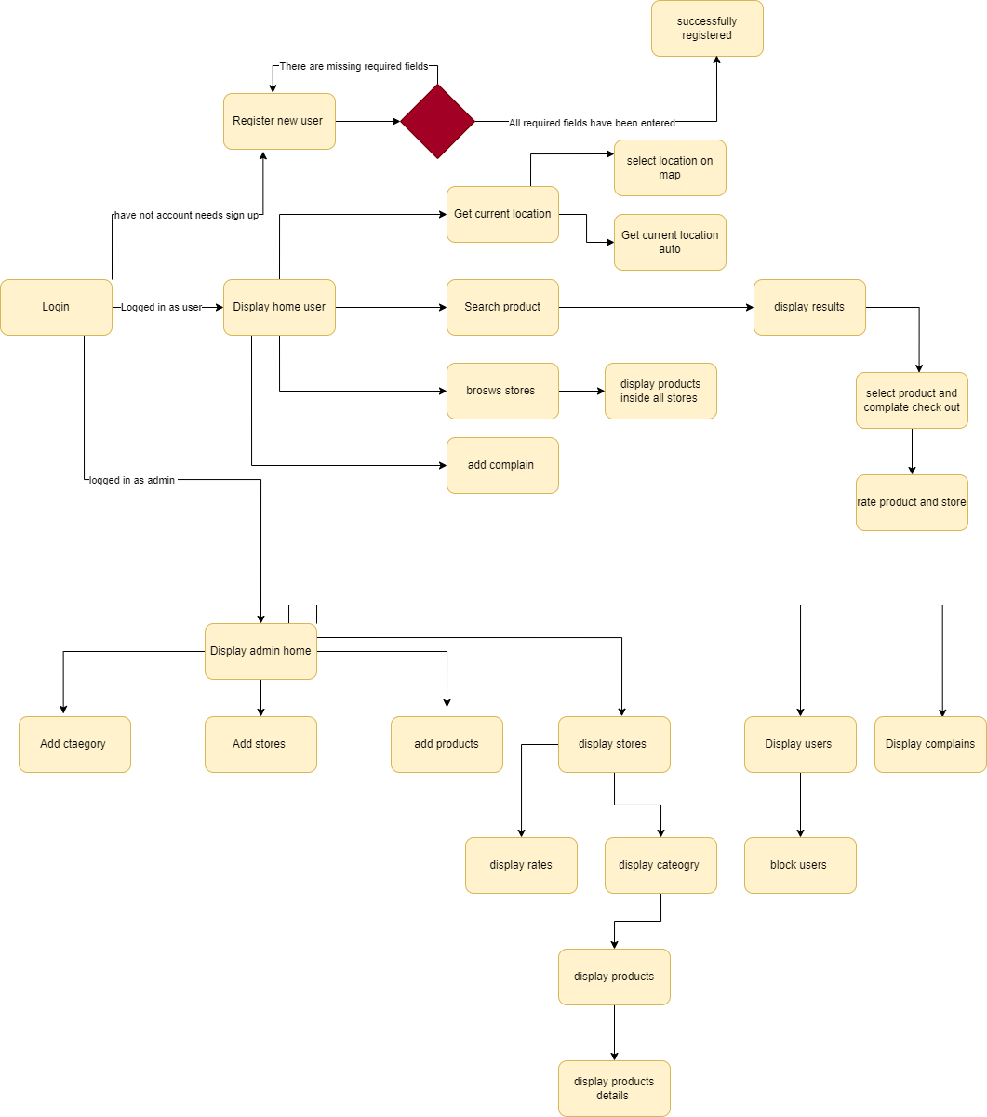

Figure 1 - work flow diagram

# System Security Requirement

1. Use Secure Sockets Layer Connection certificate on server

Secure Sockets Layer known as (SSL), it means the secure communication layer that builds an encrypted connection between the server and the client, and it is one of the very important protocols in the security of Internet sites and the exchange of digital information.

1. Password format
   * The password must contain a large group of digits, the number of which is not less than 10
   * The password must contain uppercase and lowercase letters and symbols
   * The password must be strong so that it cannot be guessed. Consistent forms of letters or consecutive numbers of numbers are not accepted.
   * They are stored in the databases according to the encryption mechanisms used in storing passwords
2. Encryption of contact data and passwords

Encryption mechanisms are used to store sensitive user data on the website, as well as encrypt contact data and send the token to users in an encrypted form that does not allow it to be easily hacked.

1. Password recovery mechanism

The password recovery mechanism must be through two-factor authentication, whether it is through the registered email or mobile number

1. Registeration

It is necessary to verify the user's contact data such as e-mail and phone number through two-factor authentication and send confirmation messages to the mail and phone

1. Internet session management

Session management is represented by the presence of an encrypted token for each user that is used during one session and navigates through it through the various pages of the website smoothly and without the need to log in and verify the identity of the user more than once during the same session

1. SQL injection

We must use all prevention methods to protect the website's databases from any SQL injection

1. User authintecation
   * Authentication processes must differentiate between the permissions of each user and the pages he is allowed to access
   * Only the system administrator can add stores
   * Only the System Administrator can add the different product categories
   * Only the system administrator can add products and link them to different stores and categories
   * Only the system administrator can modify or delete products, stores or categories
   * Only the system administrator can see complaints and suggestions
   * Only the admin can block different users, see requests, and change the status of each of my requests
   * Only the user can access his account, confirm his geographical location, search for comparisons of different products and choose one

# Non-Functional Requirements

In this table will display non-functional requirements

|  |  |  |
| --- | --- | --- |
| Constraint Number | type | Constraint Description |
| C1 | Reliability | * The website must be compatible with all different screen sizes * The design is understandable, attractive and self-explanatory so that different users can use it |
| C2 | Performance | * The site must be very fast so that the user does not get bored when browsing it * It is compatible with all kinds of different browsers * In the event of a server crash, a message must appear explaining to the user that the site has some temporary maintenance * In the event that the server is late in responding to the client, it is necessary to clarify the location of the problem * Detailed messages appear to the user when any problem occurs during use, explaining the cause of the problem and how to solve it, if possible |
| C3 | Economic | * Server cost will be 825 rs |

# Class Diagram

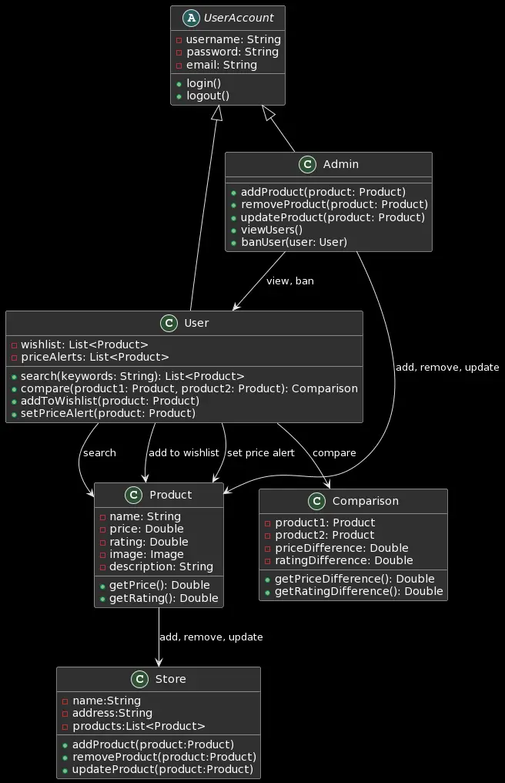

Figure 2 - class diagram

# System mockup

## Login

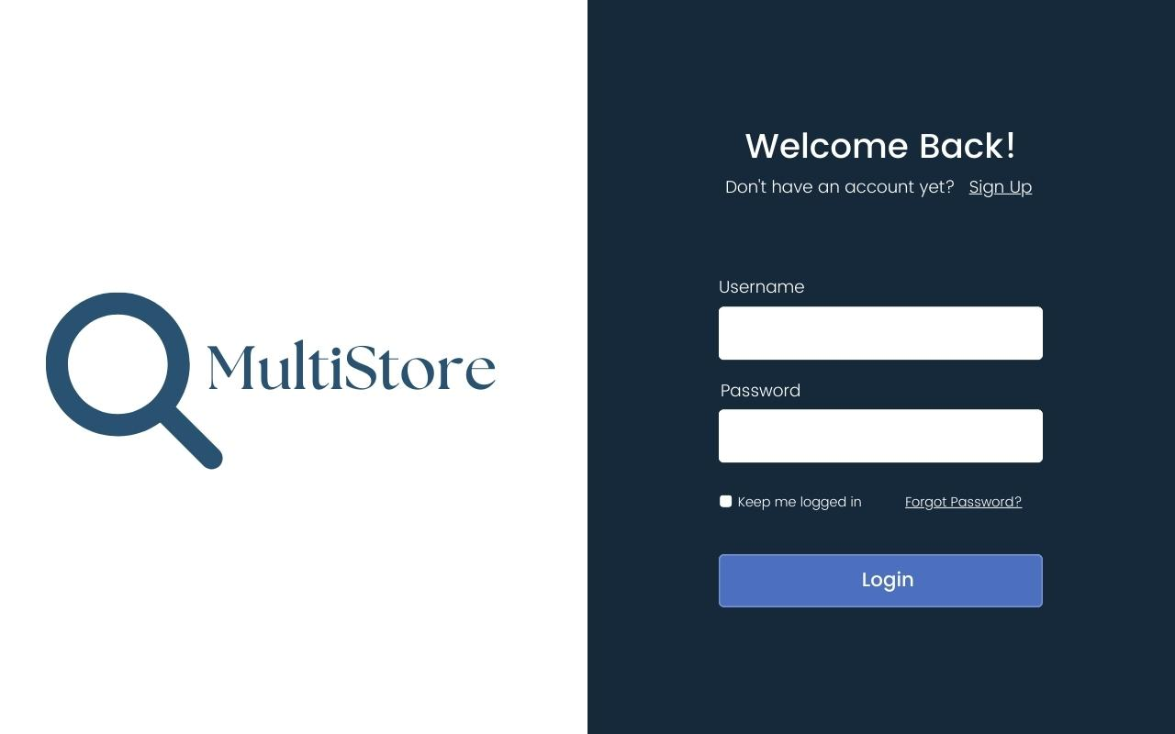

Figure 3 – Login

## Add category

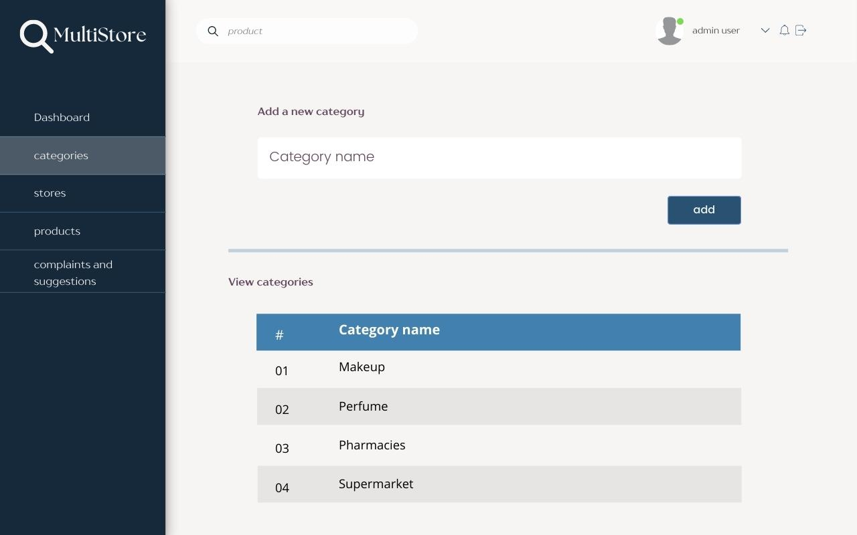

Figure 4 – add category

## Add product

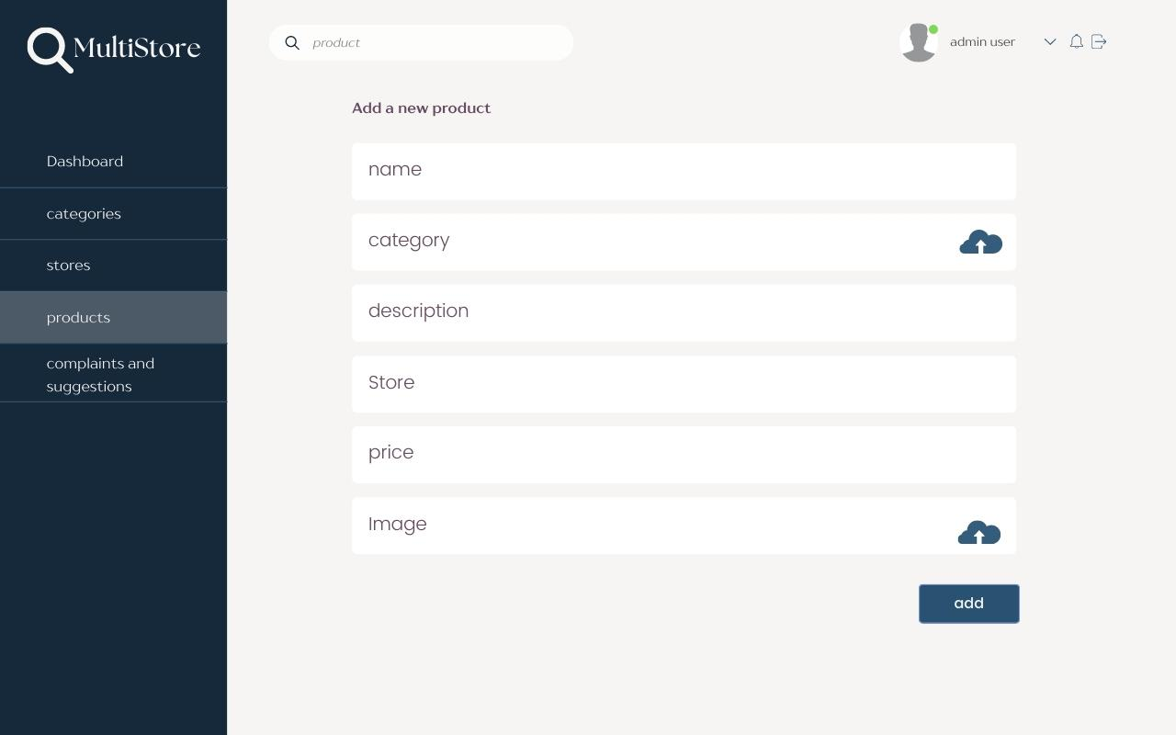

Figure 5 - add product

## Add store

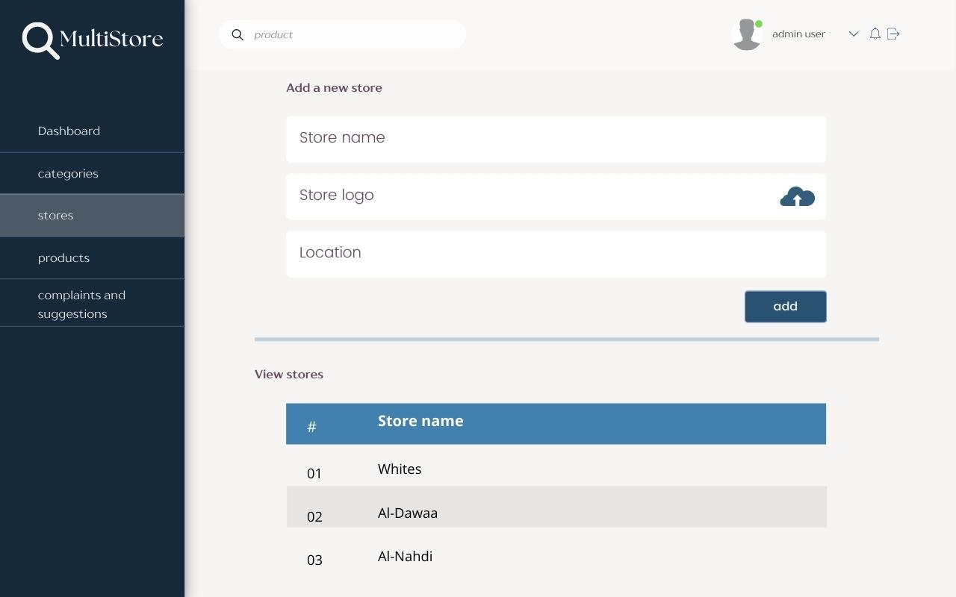

Figure 6 - add store

## Products

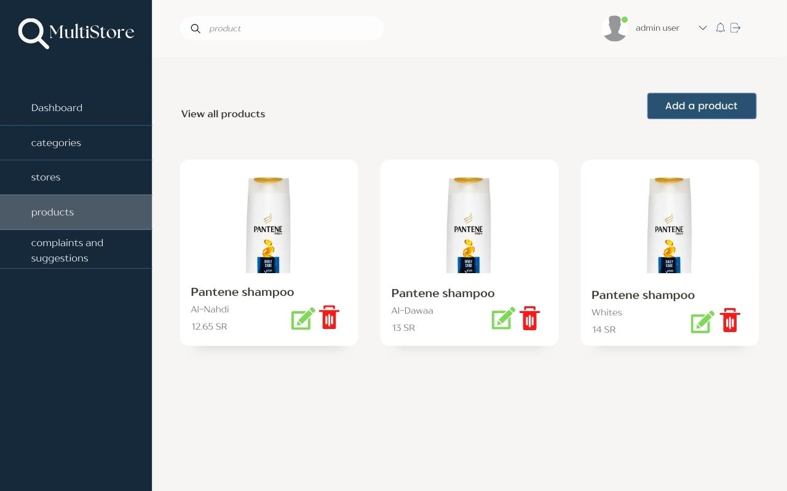

Figure 7- products when logged in as admin

## Complains

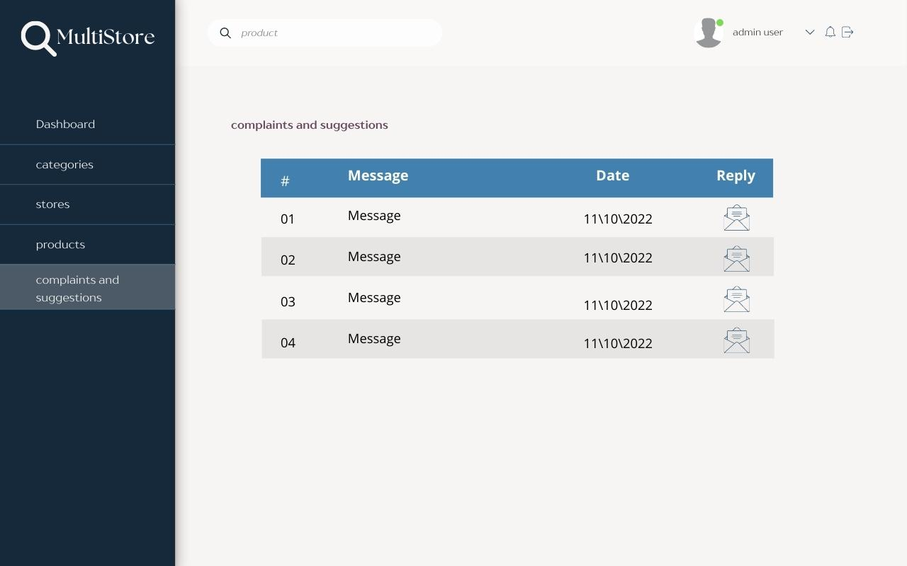

Figure 8 - complains on manger account

## Search on user account

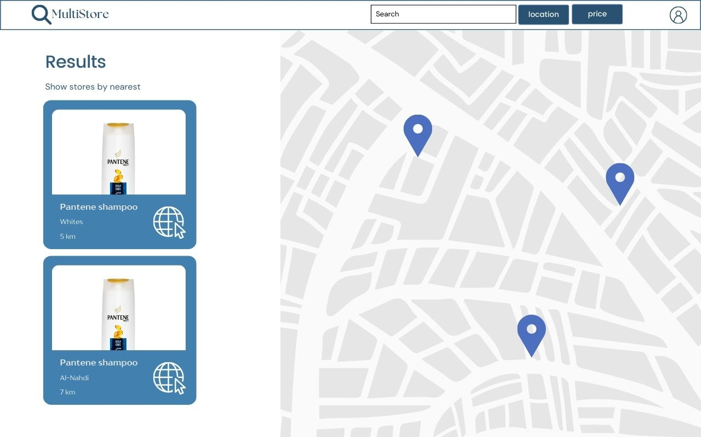

Figure 9 – Search

## Results

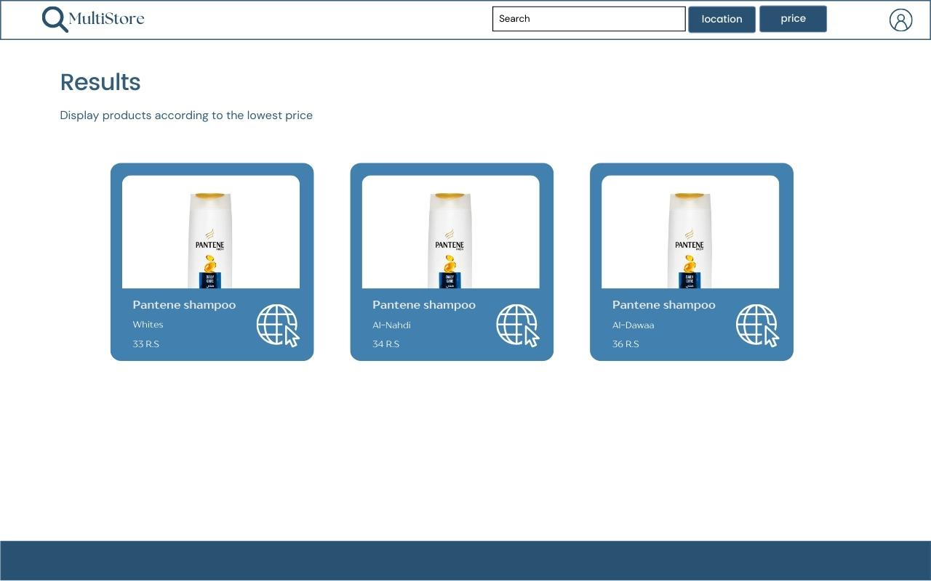

Figure 10 - Results on user account

# Risk Assessment

|  |  |  |
| --- | --- | --- |
| Risk(s) | Potential Impact | Risk Mitigation |
| Change prices on store websites | When you talk about prices in a store and they are not updated through our website, this matter would mislead the buyer and make him make the wrong purchase decision. | We will make a request to update the prices every 30 minutes and in some vulnerable products we will reduce the waiting time for the update to be faster |
| Authentication process | An attempt to log in through the site may be done by password guessing tools | We will work to strengthen passwords and ensure that the user will set a password that is difficult to hack and guess by using an appropriate length and that the password contains numbers, symbols and letters |
| Overlapping categories | There are some products that can fall under more than one category, so you find some stores put them in one category and some other stores put them in a different category. | We will work to adopt our own division of products, and we will not rely on division of stores |
| Compare the quality of products | Knowing the quality of products is difficult for us to determine with high accuracy in order to help users make the right decision | We will rely on the reviews of previous users |
| project time | The project may extend to a significant amount of time |  |

Table 1 - Risk Assessment

# Standards

We will use in this project:-

* UTF-8 (Unicode Transformation Format 8-bit) is a character encoding standard that is widely used for encoding text on the Internet and in other digital communication systems. It is part of the Unicode standard, which is an international standard for representing text in a wide variety of scripts and writing systems.
* ERD (Entity Relationship Diagram) is a graphical representation of entities and the relationships between them in a database. The standard for ERD is defined by the notation known as the Chen notation, which was developed by Peter Chen in 1976.
* APA (American Psychological Association) style is a widely used citation and formatting style for academic documents, particularly in the social sciences. The standard for APA style is defined in the Publication Manual of the American Psychological Association, which is currently in its 7th edition.
* OWASP (Open Web Application Security Project): This is a widely recognized standard for web application security that provides guidelines and best practices for securing a website.
* W3C (World Wide Web Consortium): This organization sets standards for web technologies, including HTML, CSS, and JavaScript. Following W3C standards ensures that your website will be compatible with a wide range of web browsers and devices.
* ISO/IEC 27001: This standard provides guidelines for an information security management system (ISMS) and can be used to secure a website and protect sensitive information.
* PCI DSS (Payment Card Industry Data Security Standard): This standard applies to organizations that accept credit card payments and provides guidelines for protecting sensitive payment information.
* HIPAA (Health Insurance Portability and Accountability Act): This standard applies to healthcare organizations and provides guidelines for protecting personal health information (PHI).
* SQL (Structured Query Language): This is the standard language for managing and manipulating relational databases. The standard for SQL is defined by the International Organization for Standardization (ISO) and the International Electrotechnical Commission (IEC) in the ISO/IEC 9075 standard.

# High level architecture

## **UseCase diagram**

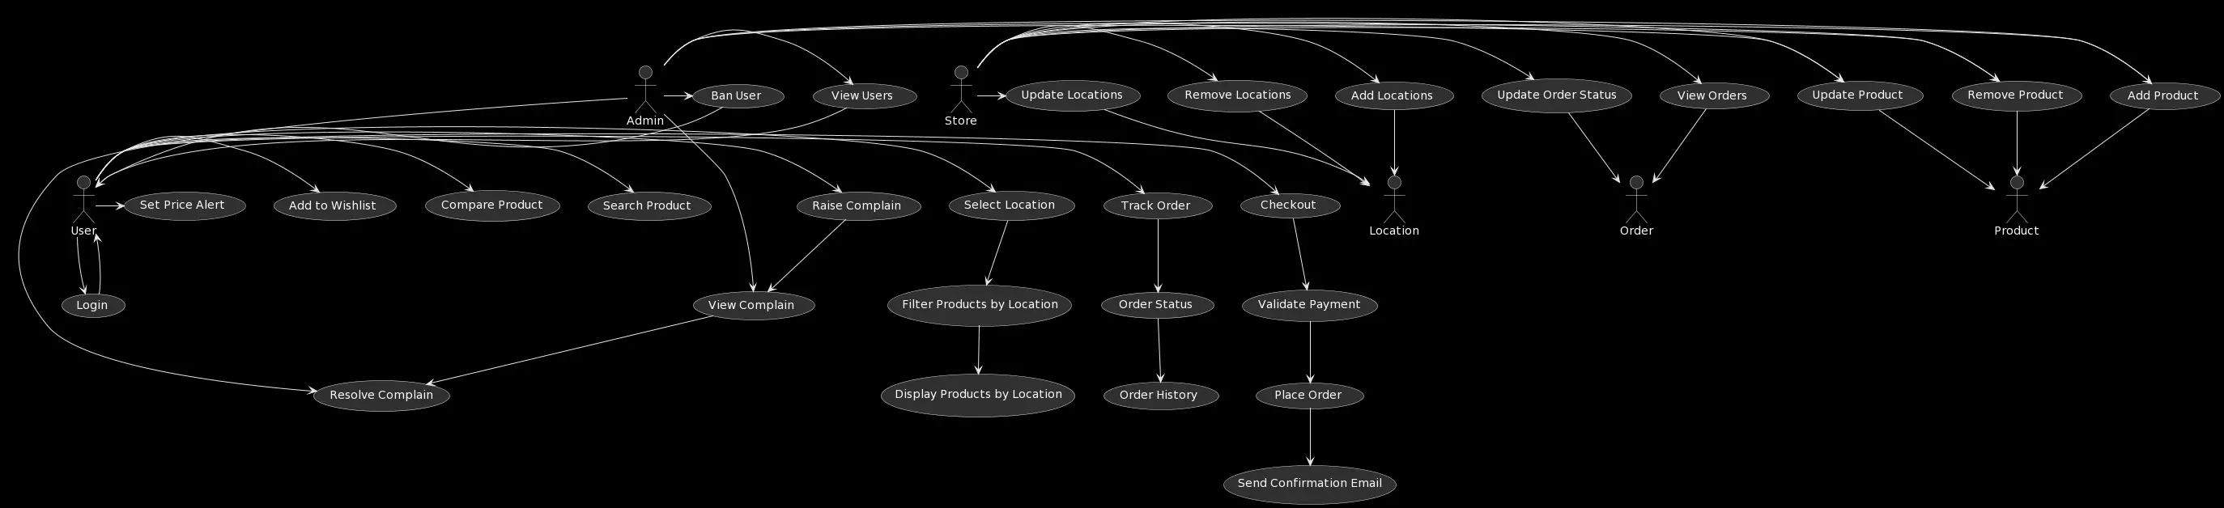

Figure 11 - use case diagram

## **Activity Diagram**

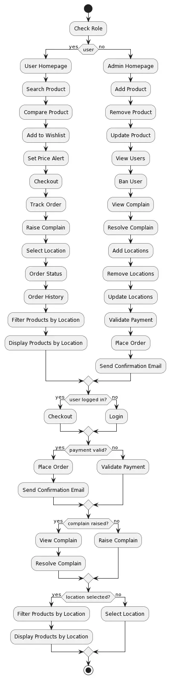

Figure 12 - acivity diagram

# Tools and Processes

* SQL Server
* Visual studio
* Windows 10
* Chrome browser
* Drow io
* Adobe xd

# Project Plan

|  |  |  |  |  |
| --- | --- | --- | --- | --- |
| Tasks | Oct week1 | Oct week2 | Oct week3 | Oct week4 |
| Introduction | √ |  |  |  |
| Justification | √ |  |  |  |
| Feature system |  | √ |  |  |
| Detailed requirements |  |  | √ |  |
| System requirement |  |  |  | √ |
| Workflow diagram |  |  |  | √ |
| System secuirty |  |  |  | √ |
|  | Nov Week1 | Nov Week2 | Nov Week3 | Nov Week4 |
| Functional requirement | √ |  |  |  |
| Non-Functional requirement | √ |  |  |  |
| Class diagram |  | √ |  |  |
| System mokup |  | √ |  |  |
| Risk Assessment |  |  | √ |  |
| Diagrams |  |  | √ |  |
| Results |  |  |  | √ |
|  | Jan Week1 | Jan Week2 | Jan Week3 | Jan Week4 |
| Design databas |  |  |  |  |
| Design user interfaces |  |  |  |  |
| Design admin interfaces |  |  |  |  |
| Connection with db |  |  |  |  |
| Testning design user |  |  |  |  |
| Testing design admin |  |  |  |  |
|  | Feb Week1 | Feb Week2 | Feb Week3 | Feb Week4 |
| Fix bugs with interface |  |  |  |  |
| Display connection result admin |  |  |  |  |
| Display connection result user |  |  |  |  |
| Testing connection |  |  |  |  |
|  | Mar week1 | Mar week2 | Mar week3 | Mar week4 |
| Fix issues |  |  |  |  |
| Final testing all system |  |  |  |  |
| Final Fix issues |  |  |  |  |
| Fully working deom |  |  |  |  |
| Report and PPT Presentation |  |  |  |  |

Table 2 - project plan table

# Sub-Team Responsibilities and Team Structure

The team work in this project consisted of:-

1. Sara Alqahtani
2. Expertise
   * Good knowledge with UI
   * Good with UX
3. Responsibilities
   * Create UI
   * Create UX
   * Helping team with report and PTT
4. Maryam Alghafli
5. Expertise
   * Good with Design database
   * Good experience with drawing diagrams
6. Responsibilities
   * Create diagrams
   * Create database
   * Helping team with report and PTT
7. Rawan Alshammari
8. Expertise
   * Good with using .net
   * Good experience with connection with db and ui
9. Responsibilities
   * Create code .net
   * Create connection with database
   * Helping team with report and PTT

# Expected Results

We have worked diligently and diligently on this project to be attractive and strongly competitive and to achieve more progress in online shopping operations and to prevent exploitation, raising prices and marketing products by exploiting the customer's ignorance of the prices of the same products on competing platforms and we do not believe that there are many sites that offer the same what we do With it, we have striven to provide everything that can facilitate the electronic purchase process for customers, as well as increase the percentage of sales for stores that offer prices

# REFRANCE

[1]. Visual Paradigm. (2019). *What is Use Case Diagram?* Visual-Paradigm.com. <https://www.visual-paradigm.com/guide/uml-unified-modeling-language/what-is-use-case-diagram/>

[2]. tutorialspoint.com. (2019). *UML - Class Diagram*. Www.tutorialspoint.com. <https://www.tutorialspoint.com/uml/uml_class_diagram.htm>

[3]. *How to Create an Activity Diagram [+Examples]*. (2022, April 28). Venngage. <https://venngage.com/blog/activity-diagram/>

[4]. *Google - Outsourcing Portal*. (n.d.). Partner-Security.withgoogle.com. <https://partner-security.withgoogle.com/docs/webapp_requirements.html>

‌

‌

‌

‌